YES Prep Student Device Guide:
6th – 12th Grade

Student Login Credentials: Username and password for YES Prep issued device AND Microsoft Teams (platform to access virtual classes)
STUDENT NAME | «Student_Name»
STUDENT ID | «Student_ID»
GRADE | «Grade»
USERNAME | «Username»
PASSWORD | «Password»

Step 1: Log on to your YES Prep device
Using your own device for virtual learning? Start at Step 2.
- Power on.
- Connect to the internet.
- Use the login credentials above to login to your YES Prep issued device.
Step 2: Sign into Microsoft Teams
- If your computer has Microsoft products installed, click on the Microsoft Teams icon (if you cannot locate this icon, follow step 4):
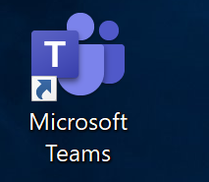
- Login to Microsoft teams with your login name/email. Click next.
- Enter your password. If you have not changed it, the standard password is: YesStudents17
- If you cannot access Microsoft Teams through the icon you can always log in online.
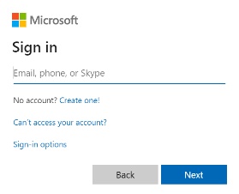
  - Open a web browser (Chrome or Internet Explorer)
  - Go to www.office.com.
  - Click on the logo in the top right corner to sign in
  - Then enter your Teams login name/email. Click next.
  - Enter your password. If you have not changed it, the
Standard password is: YesStudents17
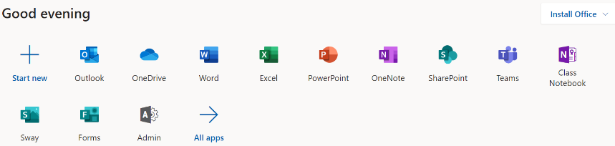
  - Once you are fully logged in, you will see something
like this:

- Click on the Teams icon and get started!
Student Technical Support
Having trouble logging into your YES Prep issued device or Microsoft Teams account?
If your username and/or password is not working, please complete the YES Prep Student Support: YES Prep Account survey at https://yespreporg.finalsite.com/covid19/tech-support which is accessible through any internet browser, smart phone and computer. Your campus operations teams will reach out to you via phone once your password is reset.
- If you are unable to complete the survey, please call the Hobby Front Office at (713) 842-5600 between 8:30 a.m. to 3:45 p.m. Monday through Friday for support.

Having trouble completing assignments, accessing platforms, website, or having computer issues?
- Reach out to your Homeroom teacher via Microsoft Teams. Your Homeroom teacher will reach out to IT on your behalf and assist you with technical problems.
- If you are unable to turn on your computer or have a black screen, please contact your campus front office.

